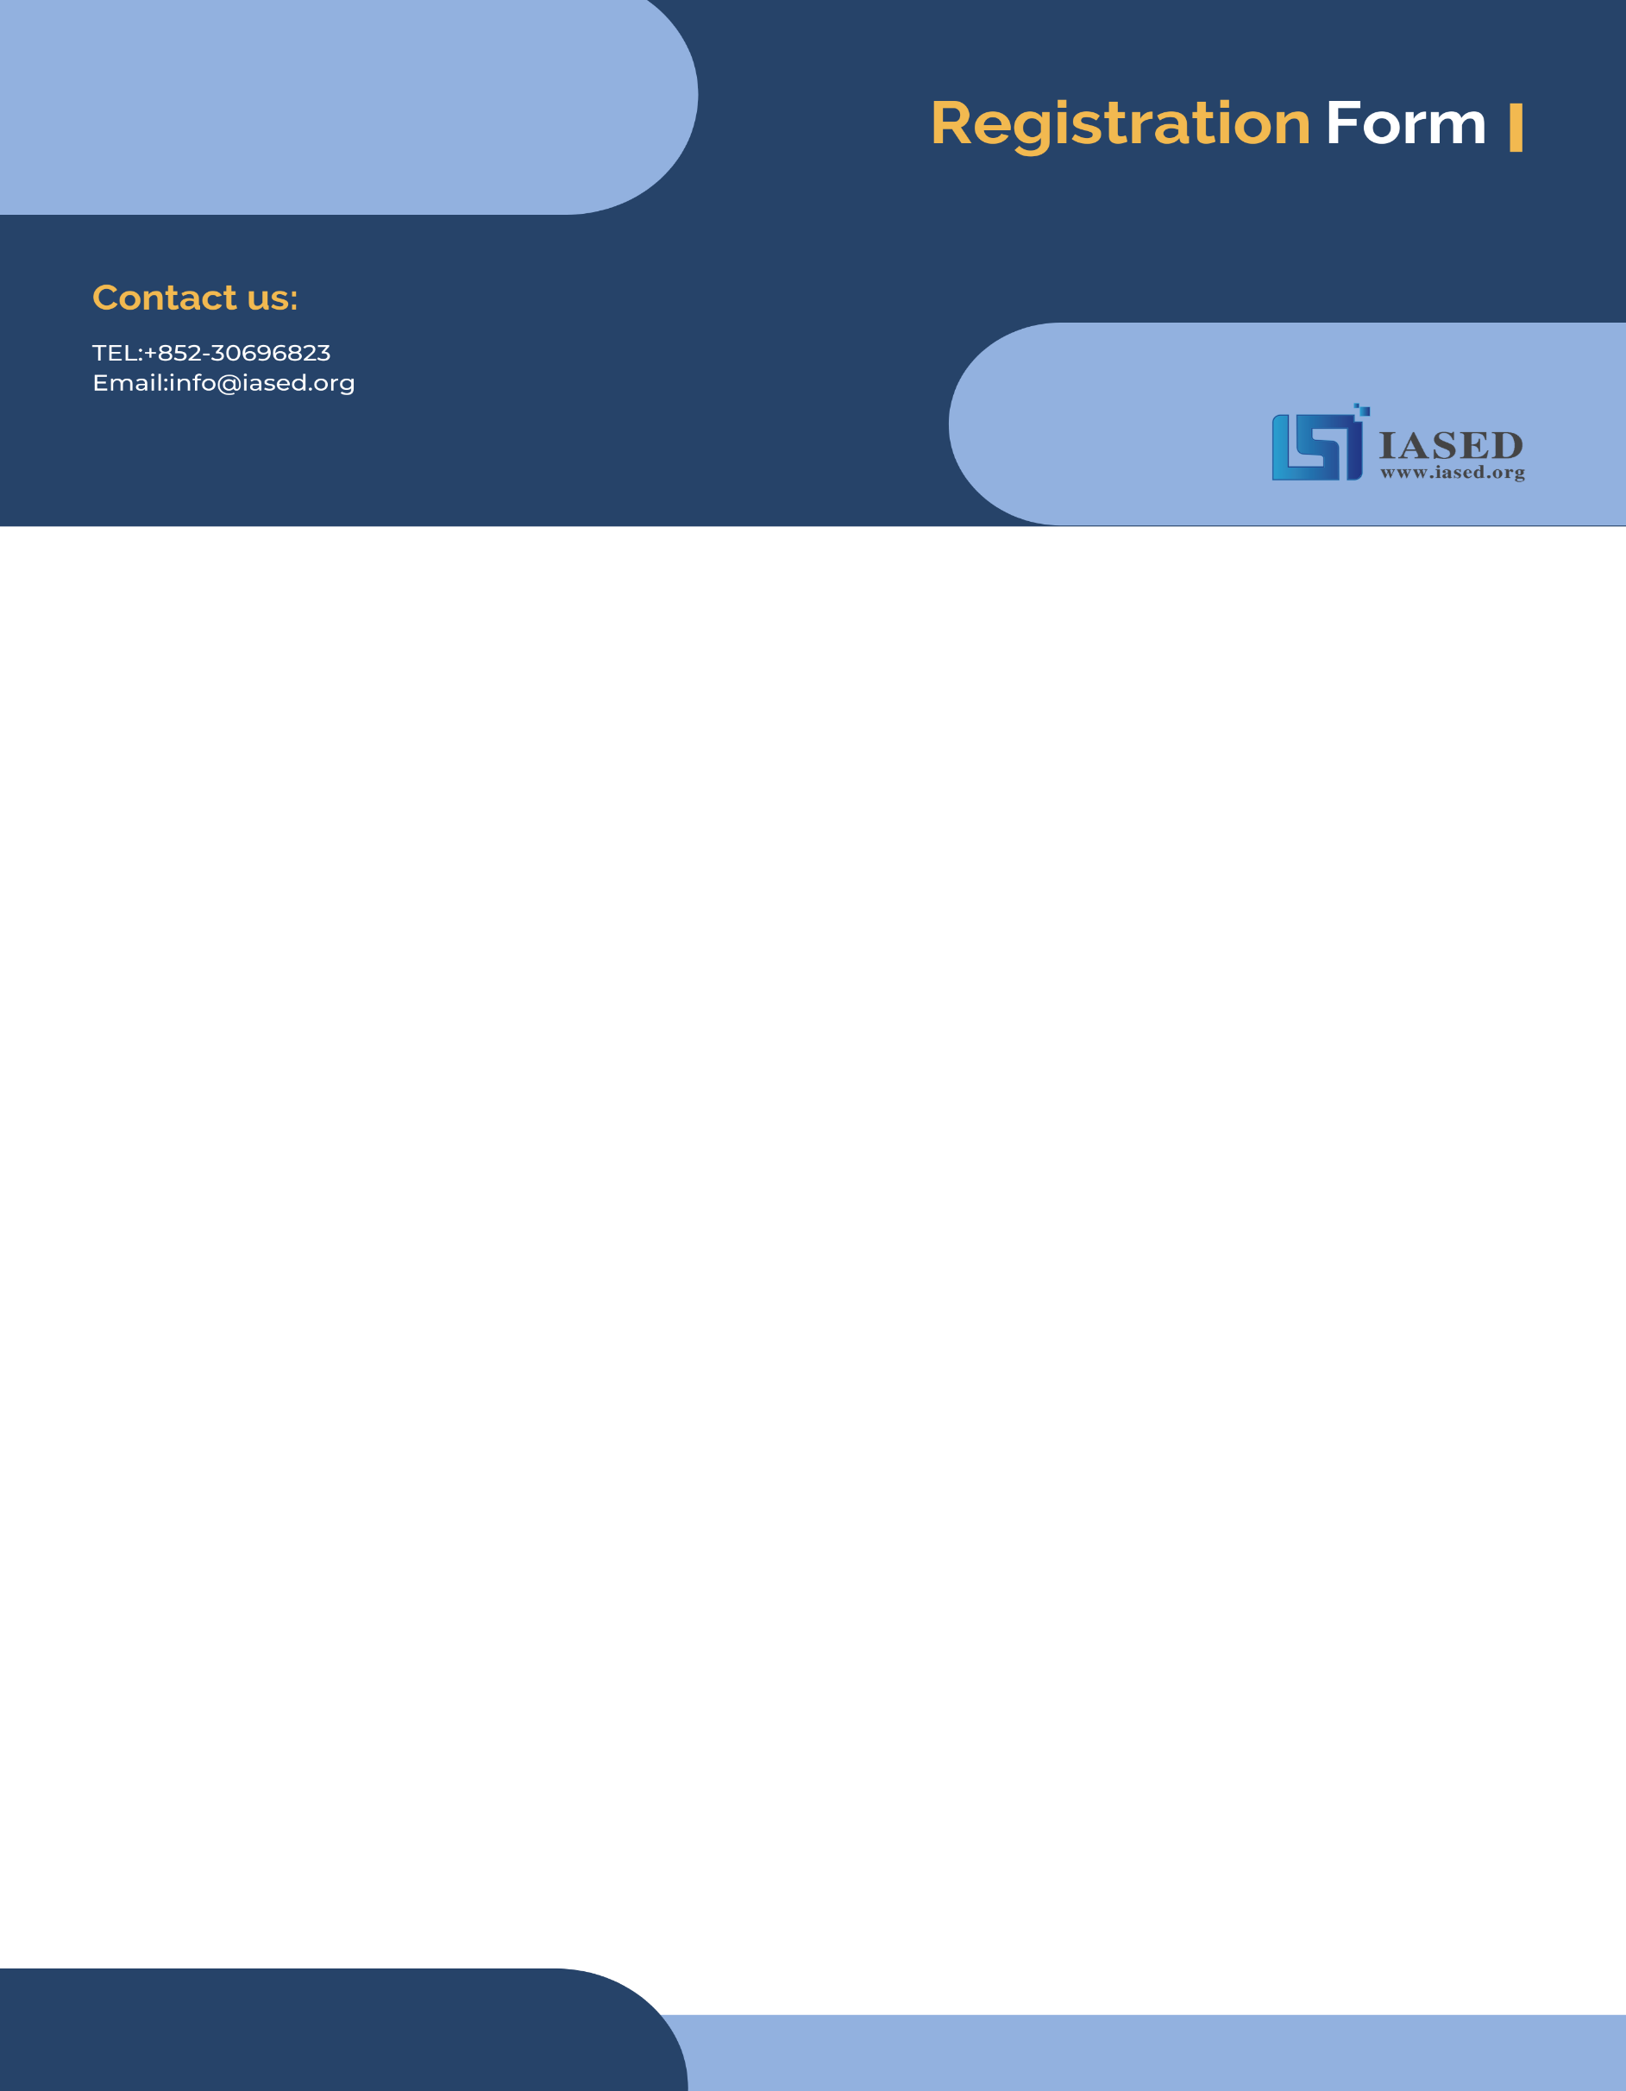
NOTE: Make sure to submit all required documents: 1. final paper (doc & pdf files), 2. completed registration form, 3. Payment Voucher to contact@jcice.org. (Mail Subject: Paper ID + Registration).
2024 International Joint Conference on Information and Communication Engineering (JCICE 2024)
May 10-12 | Fuzhou, China | www.jcice.org.
- ATTENDEE INFORMATION
*Full Name:
*Position√: Prof. Assoc. Prof. Asst. Prof. Dr. Mr. Ms.
*Affiliation & Nation:
*Email:
*Mobile Phone:
*Alternative Liaison (Name & Mobile):
Address& Zip Code (for post use):
Catering (On-site conference on May 11): Lunch Dinner
Special dietary√: Diabetic Vegetarian Halal food Other (please specify: )
Special requirements:

- PAPER INFORMATION
*Paper ID: *Paper Pages: *Extra Page(>5 pages):
*Paper Title:
*Authors:
*Will you be present at the on-site conference? Yes No
*Presentation Type√: Oral Poster
*Participation Certificate√: Softcopy Hardcopy I do not need the certificate
Student ID No. (student only):
IASED Member No. (member only):
* Receipt Issued to:

- PRICE INFORMATION
Onsite Conference
Category | Early  (due by Jan. 10, 2024) | Regular Registration | On-site  (May 10, 2024) | Your Choice
Full Paper  (IASED Member) | 500USD | 550USD | 600USD
Full Paper  (Nonmember Author) | 450USD | 500USD | 550USD
Full Paper  (Student Author) | 470USD | 520USD | 570USD
Abstract (Regular Author) | 400USD | 450USD | 500USD
Abstract (Student/Committee) | 350USD | 400USD | 450USD
Abstract (IASED Member) | 380USD | 430USD | 480USD
Listener\Co-Author | 250USD
Others
Additional Page | 70USD
Extra Paper Upload | 300USD
Printed Conference Proceeding | 60USD
Extra Banquet Ticket | 50USD
City Tour\Social Networking Event (Optional) | TBD
Notice
*If the paper exceeds 5 pages, the additional pages will be charged. The recommended general length limit is 5-14 pages per paper, and no less than 4 pages.
*All papers will be published online.
*For "No shows", registration fee is nonrefundable.
*Shall the conference is delayed or prevented (directly or indirectly) by the reasons of natural disasters, war, strike(s), epidemic or any other events which could not be controlled, the organizing committee shall be under no liabilities. The organizing committee reserves the right to change the conference date, venue or form of the conference (online or on-site)
*Cancellation policy: Applicant should send the refund/cancellation requests to contact@jcice.org. (The Cancellation policy are available in the official website of the JCICE 2024: www.jcice.org.)
*Our payment system will not charge any extra fee, but the credit card payment may incur currency exchange charge which is charged by payers' bank, it should be borne by payers.
*One day program fee covers: Attend meeting sessions on May 11th. Only do a presentation (without publishing any papers) + coffee breaks, lunch and dinner (onsite conference) + conference kits (onsite conference).
*Full registration fee for conference covers (Onsite Author only): publication fee + meeting sessions on May 11th + 2 coffee breaks, 1 lunch, 1dinner on May 11th + conference kits.

- PAYMENT INFORMATION
Online Payment linkage
http://meeting.yizhifubj.com/web/main.action?meetingId=351
E-mail: | Confirmation Number:
* VISA /Master cards are recommended payment methods. We will not charge any handling fees, please calculate the amount before you finish the payment.  * Please fill your E-mail address used for payment and Confirmation Number you received after paying.  * As the system will intercept the email address for multiple payments, it is recommended to use different email for each payment  *Please make sure the conference organizer, IASED’s logo is always appear on the page until you click “Pay”. Then you will be directed to payment page. | 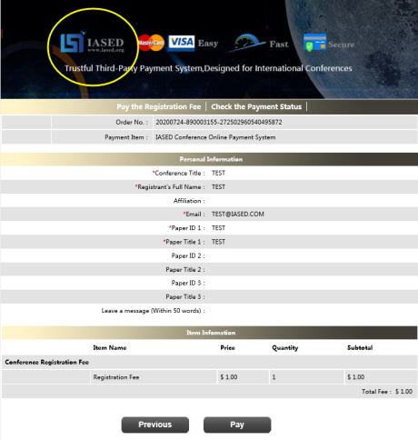
- IASED MEMBER APPLICATION
Join IASED now to quality for member registration rates. Please compile and return the Membership Form along with your CV to membership@iased.org. Your application will be processed in 5 working days.
- OTHER
Finally, we suggest you write down a biographical sketch here, for use of making introductions by Session Chair before your presentation gets started.
20-120 Words (1-3 lines)

Contact us at IASED LinkedIn:
IASED LinkedIn

JCICE 2024 Organizing Committee
Fuzhou, China

